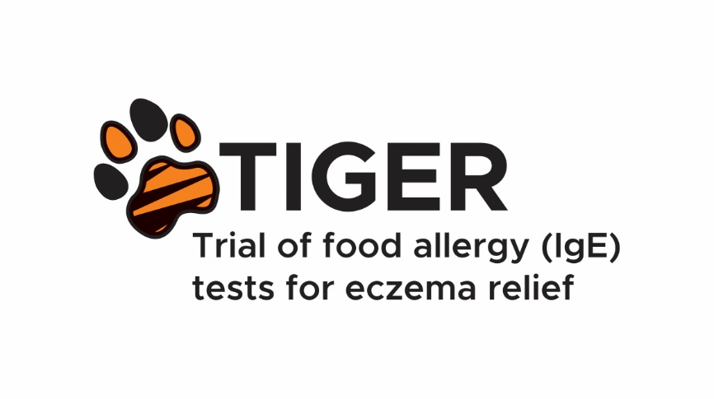

What is the study about and what does taking part involve?
1. Eczema causes dry and itchy skin | 2. Creams to moisturise the skin and treat inflammation help | 3. But parents often wonder if symptoms may be caused by an undiagnosed food allergy
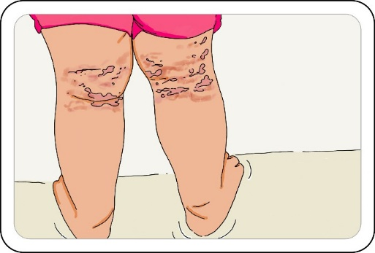 | 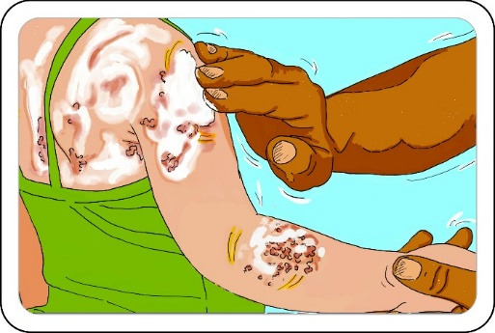 | 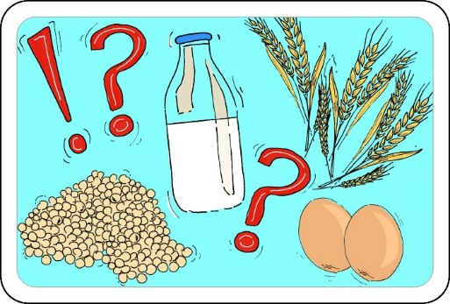
4. We do not know if making dietary changes based on food allergy tests improves eczema control | 5.This is why we need to do a “randomised controlled trial” | 6. We are inviting children 3 months to 2 years old to take part
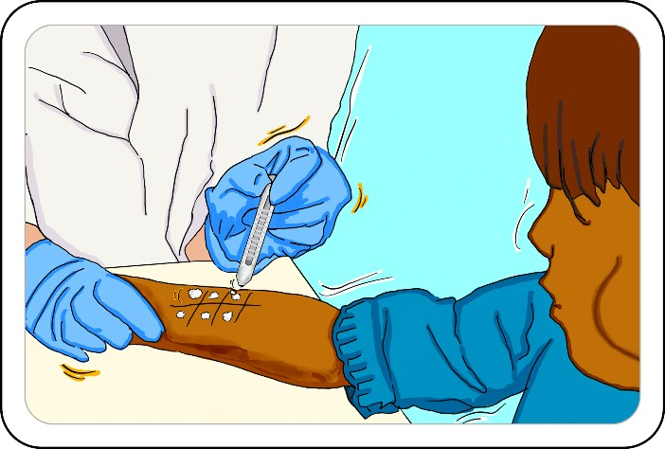 | 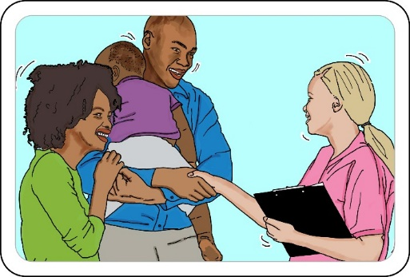 | 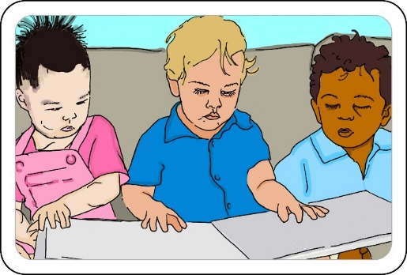
7. Half will get standard care and the other will get food allergy tests and dietary advice | 8. We will follow up everyone for 9 months | 9. At the end of the study, by  comparing the two groups we will find out the answer
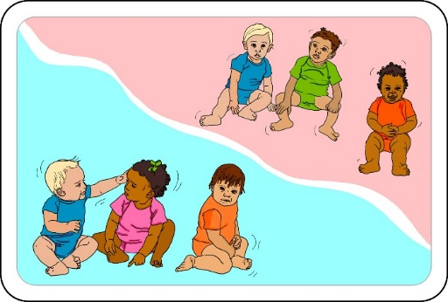 | 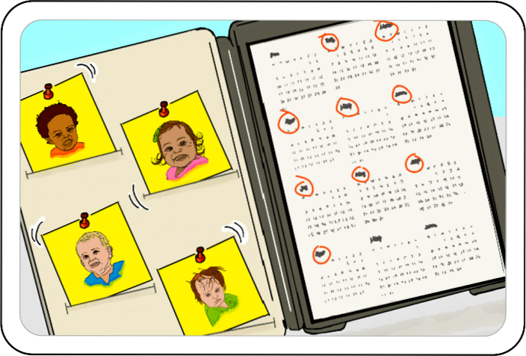 | 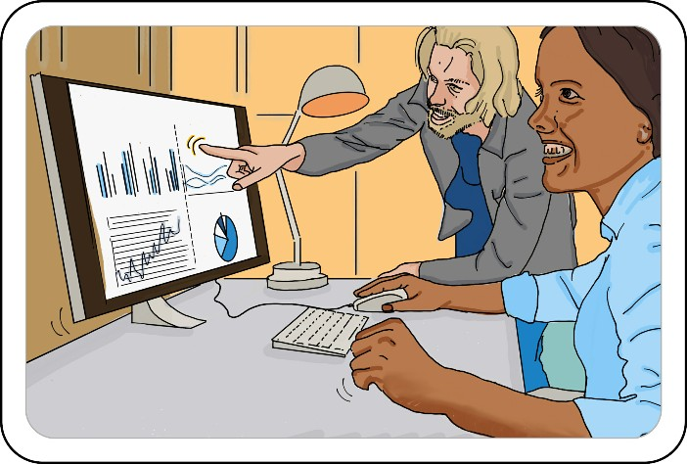

Tell me more about taking part
Nobody chooses which group your child gets put in – this is done by a computer | You will be asked to answer questionnaires every month | Your child may or may not benefit from having or not having the food allergy tests
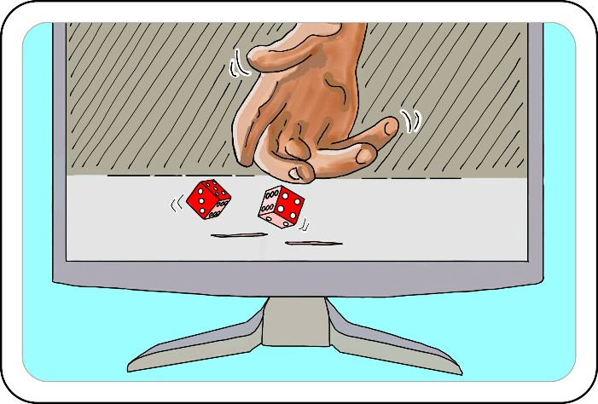 | 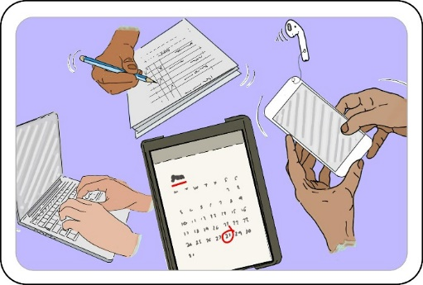 | 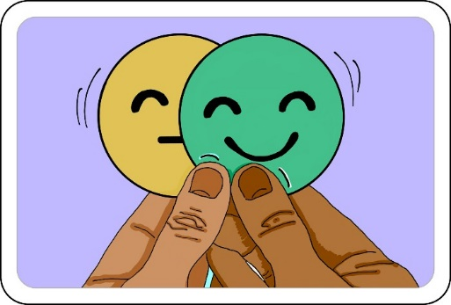
Your child can still see your doctor and any specialists as normal | The research team won’t share your personal details with anyone | If you change your mind, you can stop taking part at any time
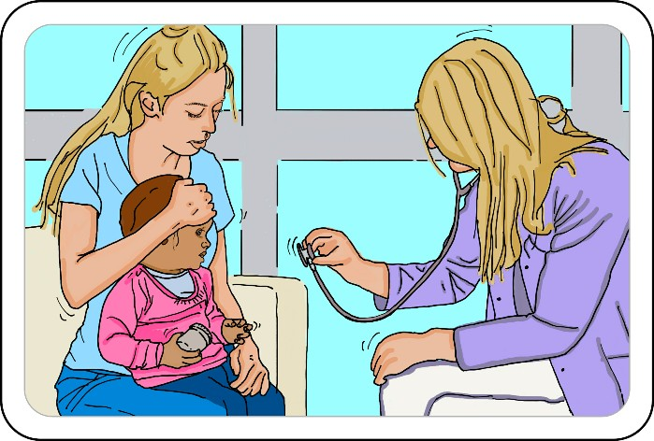 | 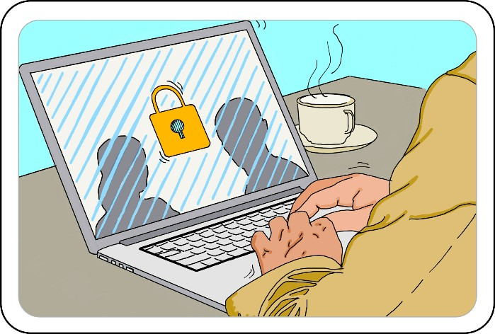 | 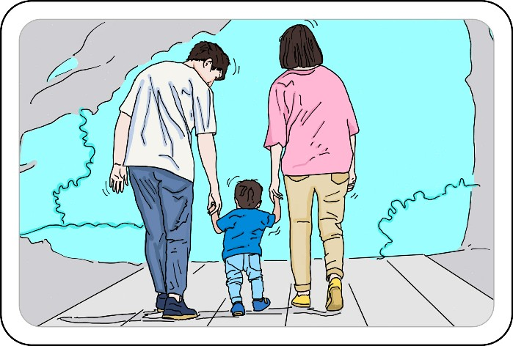

Tell me more about the food allergy tests and advice
SKIN PRICK TESTS | ORAL FOOD CHALLENGE | DIETARY ADVICE
We will look for allergies by “pricking” samples of the study foods (milk, egg, wheat and soya) into your child’s skin | For a few children, the skin prick test results will be unclear, so they will eat the food as a hospital day case patient | Depending on what the tests show, you will be asked to include or exclude each food from your child’s diet
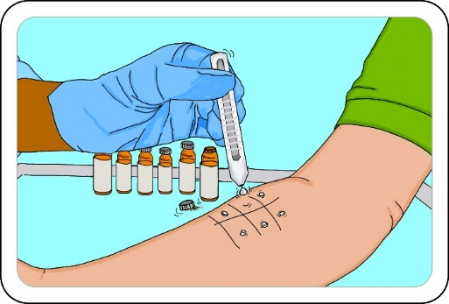 | 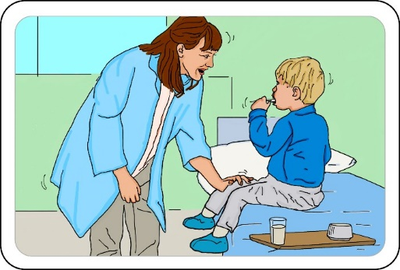 | 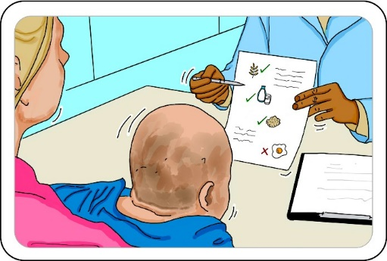
The skin prick tests are safe, and a doctor will be available if there are any problems | If your child has a reaction to the food, this is the safest place for it to be found out | If you end up excluding any foods long term, you will be able to speak to a dietitian

